L = {w|w starts and ends with the same symbol} {0,1}

solution : S → 0 S1 0|1 S1 1 |0 |1

S1 → 0 S1|1 S1|ε

possible string 0,1,00 ,11 ,010 ,101 ,000,111,0000 ,0010,0100 ,0110 ,1001 ,1101 ,0000.

L = {w||w| is odd} {0,1}

solution

S → 0 S1|1 S1

S1 → 00 S1|01 S1|10 S1|11 S1|ε

possible string 0 ,1 ,000 ,100 ,001 ,101 ,010 ,110 ,011,111 ,…..00011

class task



solution :

S -> a Sa |b S b |є

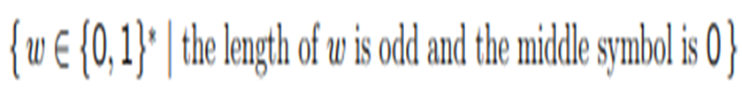

solution : 0 ,0 00 ,001,100,101

S -> 0 S 0 |0 S 1 |1 S 1 |1 S 0 |0 00011

 N>0

Solution :



solution 2:

S -> a S2 b S3

S2 -> a S2 b |є

S3 -> cS3 |є



Solution :



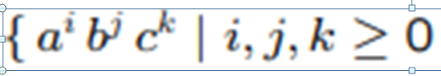

solution : I =j+k aaaaabbccc

S -> aSc |S1 |E

S1 -> aS1b |E

String end with a

Solution :

S -> Xa

X -> aX | bX |є